October 15th, 2023

Thomas Wolf

CPT242 – H02

Chapter 7 PractIce Exersizes

Tutor Management Entering Data Sample

Entering data using SQL statements:

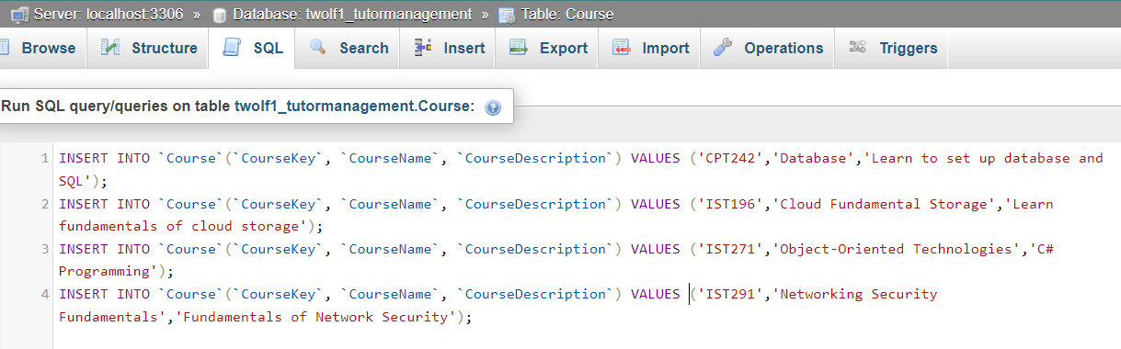

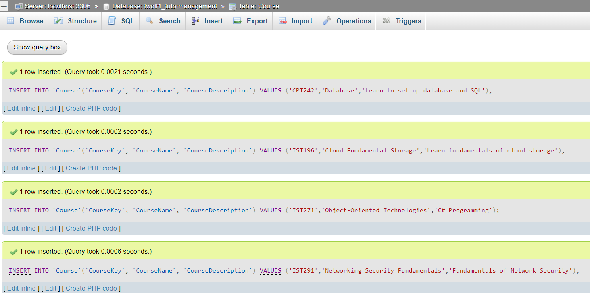

**Question** 1: Customers last names, phone numbers, and zip.

**Question** 2. Customer zip code from only 98002.

**Question** 3. Customers that have no first address.

**Question** 4. All products higher than $10.

**Question** 5. All products priced between $5 and $7.

**Question** 6. All customers whose last name starts with L.

**Question** 7. The average price of a product

**Question** 8. The highest price of a product

**Question** 9. The total due for order 1003

**Question** 10. Join the product and the OrderDetail table so that the result

contains the product name, product unit size, and product

unit price as well the charged price. Do it for order 1000.

**Question** 11. All the order and order details for each order made by

the customer with the phone number 2065556623.

**Question** 12. Change the price of breadsticks to 3.00.

**Question** 13. Process a pizza order for a new customer (this will involve 3

INSERT statements).

Insert Customer

Insert CustomerOrder

Insert OrderDetail

